**LOW LEVEL DESIGN**

**DOCUMENT**

**International Debt Statistics Analysis**

Sinchana CP

VERSION: 1.0

DATED: 23/08/2022

**Document Version Control:**

**International Debt Statistics Analysis – Business Intelligence Project**

|  |  |  |  |
| --- | --- | --- | --- |
| Version | Date | Author | Change |
| 1.0 | 23/08/2022 | Sinchana CP | First Version of  Complete LLD |
|  |  |  |  |
|  |  |  |  |

**Abstract**

It's not that we humans only take debts to manage our necessities. A country may also take debt to manage its economy. For example, infrastructure spending is one costly ingredient required for a country's citizens to lead comfortable lives. The World Bank is the organization that provides debt to countries.

This dataset provides a huge amount of information about the year wise debt by countries, debt indicators etc. Based on the Information the ultimate goal would be to predict the total sales, country with highest, highest debt indicator, total debt by each counties etc. and find important insights highlighting key indicators and metrics that impacting the debt by countries and debt indicators.

**Contents:**

1. Introduction… ....................................................................................................... 05
   1. What is Low-Level Design Document? .............................................................. 05
   2. Scope ................................................................................................................... 05
2. Architecture ............................................................................................................ 05
3. Architecture Description… .................................................................................... 06
   1. Data Sourcing… ................................................................................................... 06
   2. Data Overview… .................................................................................................. 07
   3. Data Description… ................................................................................................ 07-08
   4. Data loading in Power BI Query Editor… ............................................................. 08-09
   5. Data to Insights through Visualizations and Excel Data Analysis… .................... 09-10
4. Deployment to Power BI Service ............................................................................. 11
5. **Introduction:**

1.1 Why this Low Level Design Document

The goal of the LDD or Low-level design document (LLDD) is to give the internal logic design of the actual program code for the Bank Marketing Campaign Analysis. LDD describes the class diagrams with the methods and relations between classes and programs specs. It describes the modules so that the programmer can directly code the program from the document.

1.2 Scope

Low-level design (LLD) is a component-level design process that follows a step-by-step refinement process. The process can be used for designing data structures, required software architecture, source code and ultimately, performance algorithms. Overall, the data organization may be defined during requirement analysis and then refined during data design work.

1. **Architecture:**

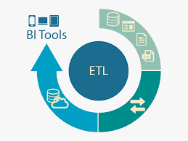

ETL (extract, transform and load) in Power BI uses preparation of data sets for analysis by removing irregularities in the data. It also involves data visualization to draw meaningful patterns and insights.

Based on the results of ETL, companies also make business decisions, which can have repercussions later.

* + - If ETL is not done properly then it can damage the business a lot in many ways such as loss of client which we are working for, the decision making will go completely wrong and many more issues.
    - If done well, it may improve the efficacy of everything we do next.

Below are following steps to follow for ETL:

1. Data Sourcing
2. Data Cleaning
3. Data Modelling
4. Data Visualization

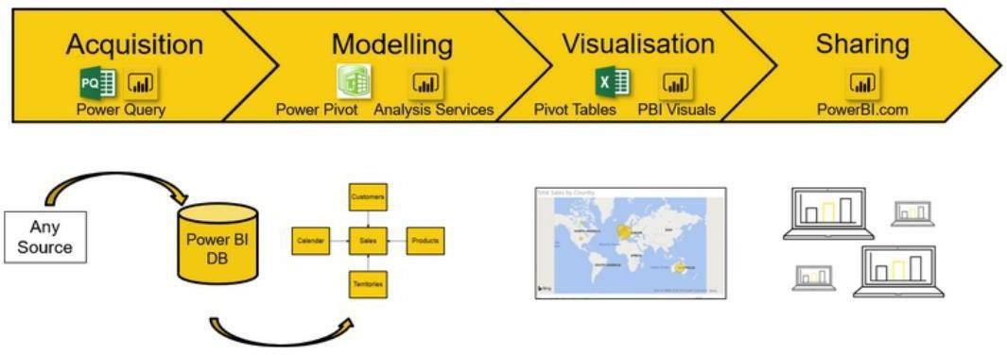

1. **Architecture Description:**

* 1. Data Sourcing:

The dataset is in Excel format. MS Excel is used to load the data.

Citation Request:

This Dataset is publicly available for research, Available at

* + 1. [https://datacatalog.worldbank.org/search/dataset/0038015](https://datacatalog.worldbank.org/search/dataset/0038015%20) as IDS_ALLCountries.xlsx
    2. Title –IDS_ALLCountries.xlsx
    3. Source - [https://datacatalog.worldbank.org/search/dataset/0038015](https://datacatalog.worldbank.org/search/dataset/0038015%20)
  1. Data Overview –
* The Data includes Excel file with all examples.
* The Number of Instance – for IDS_AllCountries.xlsx
* Number of attributes – 64 attributes

3.2 Data Description –

* The data contain the Countries name , Country code , Series Name, Series Code and Debt for each of the countries in year vice from 1970 to 2028

3.4 Data loading in Power BI Query Editor

Power Query is the data connectivity and data preparation technology that enables end users to seamlessly import and reshape data from within a wide range of Microsoft products, including Excel, Power BI, Analysis Services, data verse, and more with the following characteristics:

* There can be multiple rows and columns in the data.
* Each row represents a sample of data,
* Each column contains a different variable that describes the samples (rows).
* The data in every column can be a different type of data – e.g. numbers, strings, dates, Boolean etc.

3.5 Data to Insights through Visualizations

